FitTrack: Student Fitness Tracker

For this activity, I would create a simple web application (FitTrack) for the university's PE department. This application would allow a student to enter his or her student ID, name, exercise, exercise duration, and calories burned. Once the student clicks the submit button, the system would verify the information, calculate how many calories were burned per minute, and display a fitness summary. I would use HTML for the form and PHP for the server-side processing.

- Explain why a server-side scripting language is necessary for this application rather than relying solely on HTML.
HTML can enable a student to see the FitTrack form; however, HTML alone cannot fully support all necessary tasks for FitTrack. HTML can generate text boxes, a drop-down list, and a submit button; however, it cannot process this information on the server, verify the student ID, and calculate the result. As such, I will use PHP as the server-side scripting language (the code can be written to receive the student's information, verify the student's information, calculate, and return the result)
Code Example
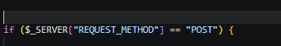

- Describe how the data entered by the student would be transmitted from the web form to the server, and how your script would retrieve and use it.
The student will enters their information required for the HTML form, and use the POST method to transfer data to the server upon submission. Each field will have a specific name, such as student_id, name, exercise, and duration, and calories, which can be retrieved by PHP using $_POST. Subsequently, the PHP script will utilize the retrieved data to produce a fitness summary, such as determining how many calories were burned per minute, i.e., dividing the calories burned by the duration of the exercise. For instance, if a student indicates 240 calories burned over 30 minutes, the calculation will yield 8 calories per minute.
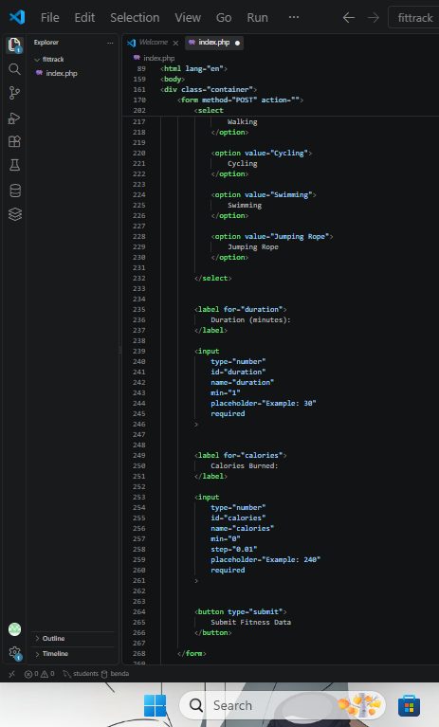
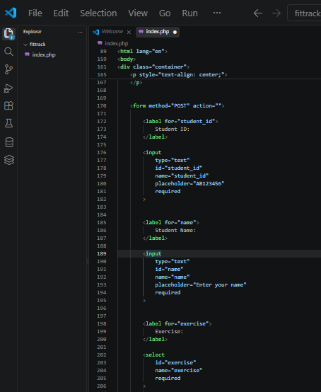
Code Example

PHP Retrieval Example
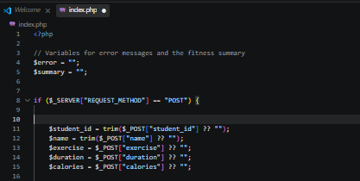

References:
[1] MDN Web Docs. (n.d.). The form element. Mozilla Developer Network.
https://developer.mozilla.org/en-US/docs/Web/HTML/Reference/Elements/form
[2] MDN Web Docs. (n.d.). HTTP request methods. Mozilla Developer Network.
https://developer.mozilla.org/en-US/docs/Web/HTTP/Reference/Methods
- Discuss how you would handle validating the student ID number on the server side.
The student ID must have a specific format (two letters followed by six numbers). I would use PHP's preg_match() function (using a regular expression) to ensure that the ID has a valid format. The ID must have exactly two letters, followed by six digits. For the student who provides an invalid ID, the system will display an error message instead of the normal process.
Code Example
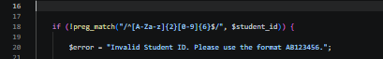

Student ID Examples
AB123456 - Valid
XY987654 - Valid
A1234567 - Invalid
ABC123456 - Invalid
12345678 - Invalid
AB12345 - Invalid

References:
[3] OWASP Foundation. (n.d.). Input Validation Cheat Sheet. OWASP Cheat Sheet Series.
https://cheatsheetseries.owasp.org/cheatsheets/Input_Validation_Cheat_Sheet.html
[4] PHP Documentation Group. (n.d.). preg_match. PHP Manual.
https://www.php.net/manual/en/function.preg-match.php
- Explain what the end user would see when they view the page source in their browser after the form is processed, and why this is significant for security.
After PHP processes the form, the server will return HTML to the browser. When the student views the page source, he or she will typically see HTML that was returned to his or her browser, including the fitness summary and other items. On the other hand, the student would not typically see the PHP code that processes the form because PHP executes on the server before returning the result to the browser.
This is important for security as the server-side code may include processing logic or other valuable information. Passwords, database passwords, and other secret information should not be included in the HTML returned to the user; however, hiding the PHP code does not guarantee the security of the application. On the other hand, the information provided by the student must be validated and processed appropriately.
Code Example
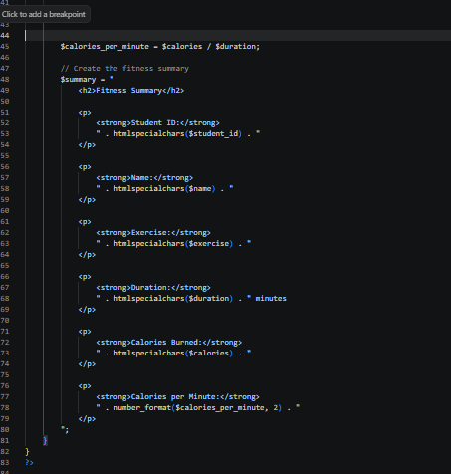
Expected Result
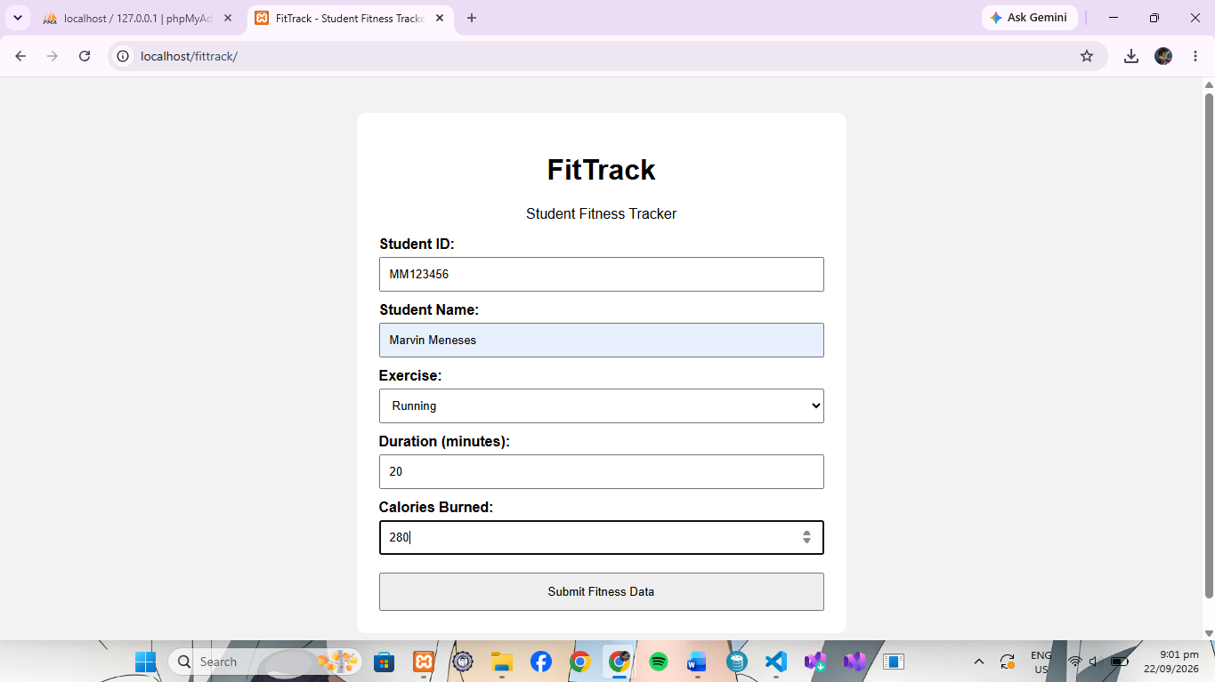

- Identify at least two potential errors a developer might encounter when writing this script and explain how those errors could be avoided.
One possible error is the use of different names between HTML form and PHP code. For instance, if the HTML form uses name="student_id", but the PHP code tries to retrieve $_POST["studentID"], the names do not match. Because of this, the PHP script may not get the expected value. I would avoid this by making sure the names in the HTML form exactly match the keys used in $POST.
Another possible error is dividing by zero. For the student who enters 0 as the exercise duration, the calculation cannot be performed correctly. I would avoid such errors by verifying that the duration is greater than zero before dividing. Another possible problem is that the student may leave required fields blank. I would validate the fields before processing and provide an error message if the fields are blank.
Code Example
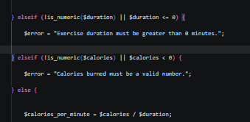

Conclusion
Overall, I would use HTML to create the FitTrack form and PHP for server-side processing. The student will enter the required information, and the form will be submitted to the server using the POST method. PHP will retrieve the information using $_POST and validate the student ID and other inputted information, calculate how many calories burned per minute, and display the fitness summary. Through input validation and error prevention, the FitTrack application can be efficient and avoid potential errors.

References
- PHP Documentation Group. (n.d.). Variables from external sources. PHP Manual.
https://www.php.net/manual/en/language.variables.external.php
- MDN Web Docs. (n.d.). The form element. Mozilla Developer Network.
https://developer.mozilla.org/en-US/docs/Web/HTML/Reference/Elements/form
- MDN Web Docs. (n.d.). HTTP request methods. Mozilla Developer Network.
https://developer.mozilla.org/en-US/docs/Web/HTTP/Reference/Methods
- OWASP Foundation. (n.d.). Input Validation Cheat Sheet. OWASP Cheat Sheet Series.
https://cheatsheetseries.owasp.org/cheatsheets/Input_Validation_Cheat_Sheet.html
- PHP Documentation Group. (n.d.). preg_match. PHP Manual.
https://www.php.net/manual/en/function.preg-match.php

